Experiment no-14
ReNew Market – Second-Hand Goods Marketplace
AIM:
To develop a second-hand shopping website with user registration, login, product listings, category management, and order administration.
PROCEDURE:
- Create registration and login forms.
- Display second-hand product categories.
- Allow sellers to add products and buyers to search products.
- Provide admin login and product management.
- Execute the program in a web browser.
Sample Code:
<!DOCTYPE html>
<html>
<head>
<title>ReNewMarket</title>
</head>
<body>
<h2>ReNewMarket</h2>
<select id="item">
<option value="5000">Used Laptop - ₹5000</option>
<option value="2000">Used Chair - ₹2000</option>
<option value="1000">Used Bicycle - ₹1000</option>
</select>
<button onclick="viewItem()">View Item</button>
<p id="out"></p>
<script>
function viewItem() {
let item = document.getElementById("item");
document.getElementById("out").innerText =
"Selected Item: " +
item.options[item.selectedIndex].text;
}
</script>
</body>
</html>
Sample Output:
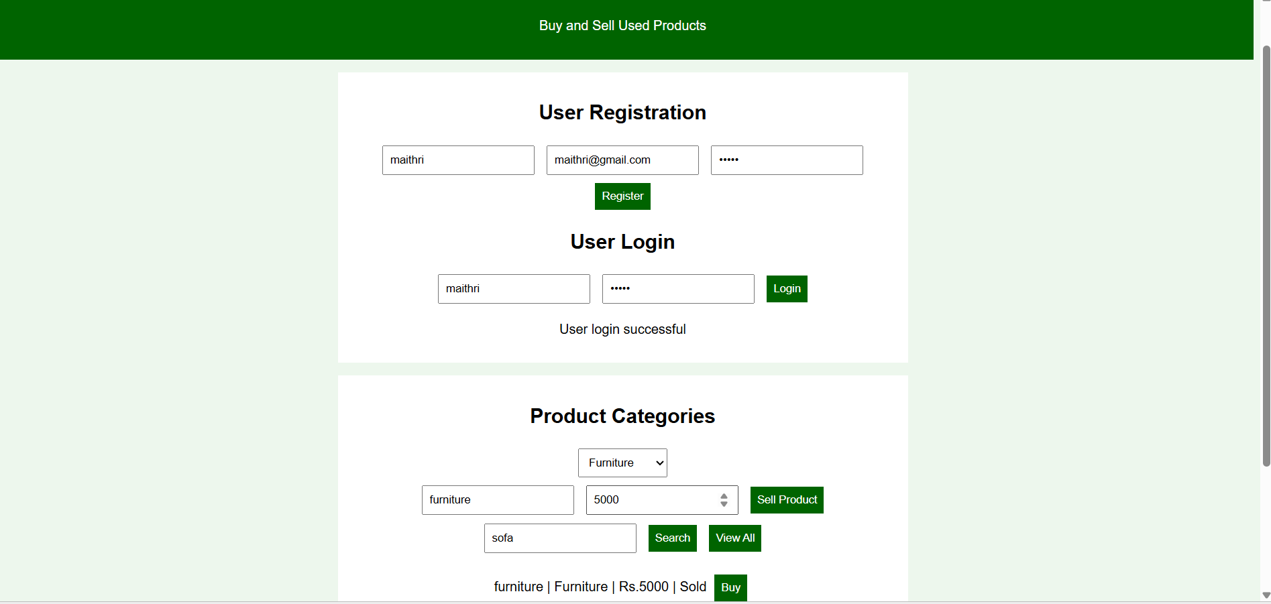
Result:
The Blossom Gifts webpage was created successfully with gift selection and cart functionality.

